Athlete Tournament Registration Instructions
This site is new. If you encounter any issues or have any questions when using this site please contact Jason Nester at 303 883 7490.

Please follow the instructions below on how to register for a tournament on the website. These instructions will cover registering for a tournament. Picking shooting time preferences, checking for squadding, and how to see the tournament leaderboard for your results once you have completed your shooting.

Log into the website. Your main page should bring you to the tournaments, but if not, select the Tournaments dropdown menu and select Browse Tournaments.

Find the tournament you want to enter and select the Register button in the bottom right corner.
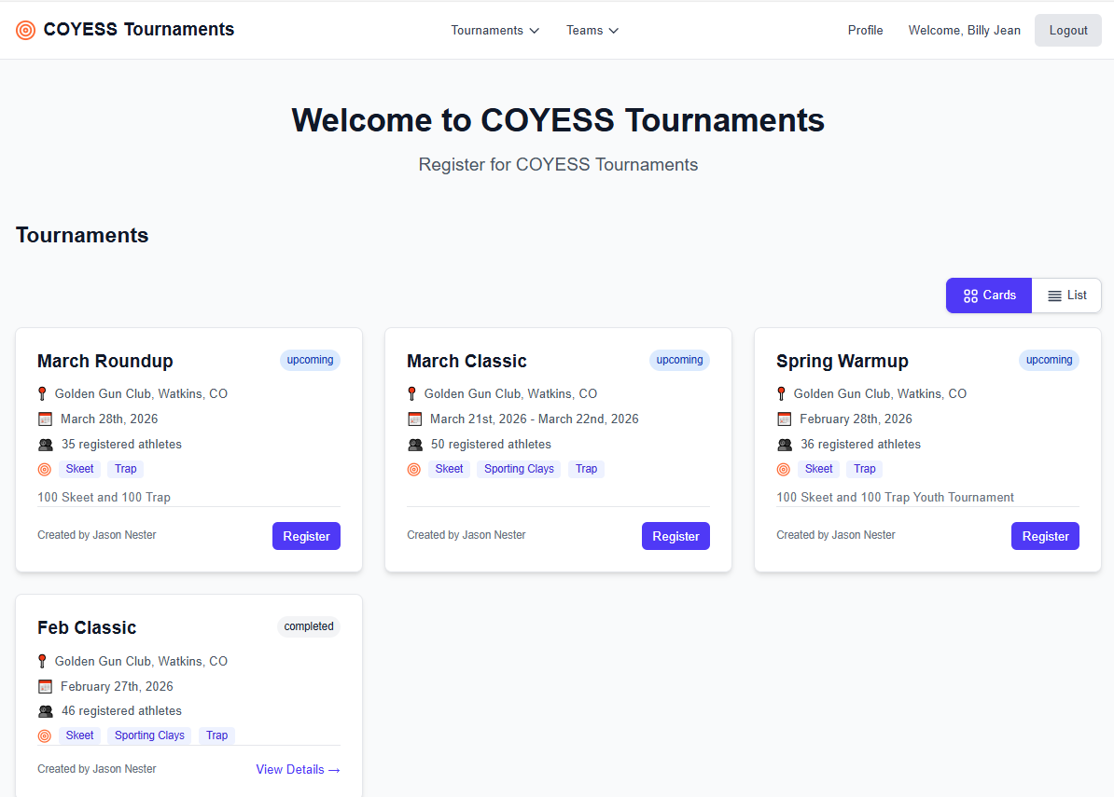
You will automatically be selected for all the events in the tournament. If you do not want to shoot all the events, unselect what you do not want to shoot.

If your coach will pick your squads and shooting times, you can just select the black box on the left and you will be registered. If you have a preference on what times you shoot or you want to guide the tournament host on what times are best for you, select the Next button.
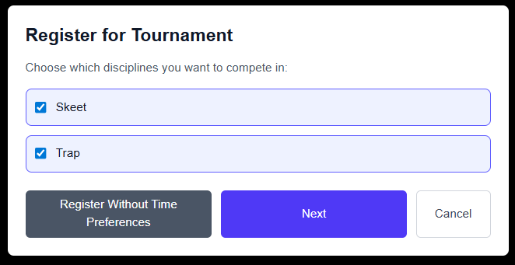

Pick the best times for each event that works for you and are still open. It is possible that some flight times may already be full. Once you have selected at least 1 choice for each event, press the Register button.
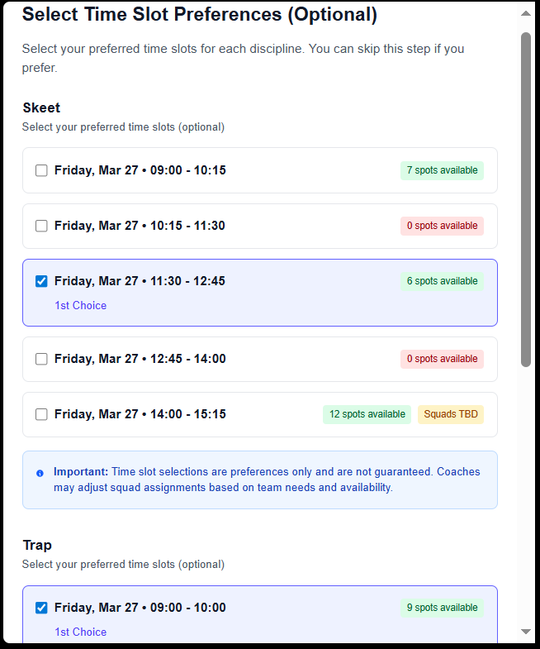
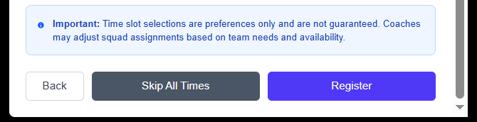
Once registered it should return you to the main page where the tournaments are listed. You should see that you are registered for that tournament.
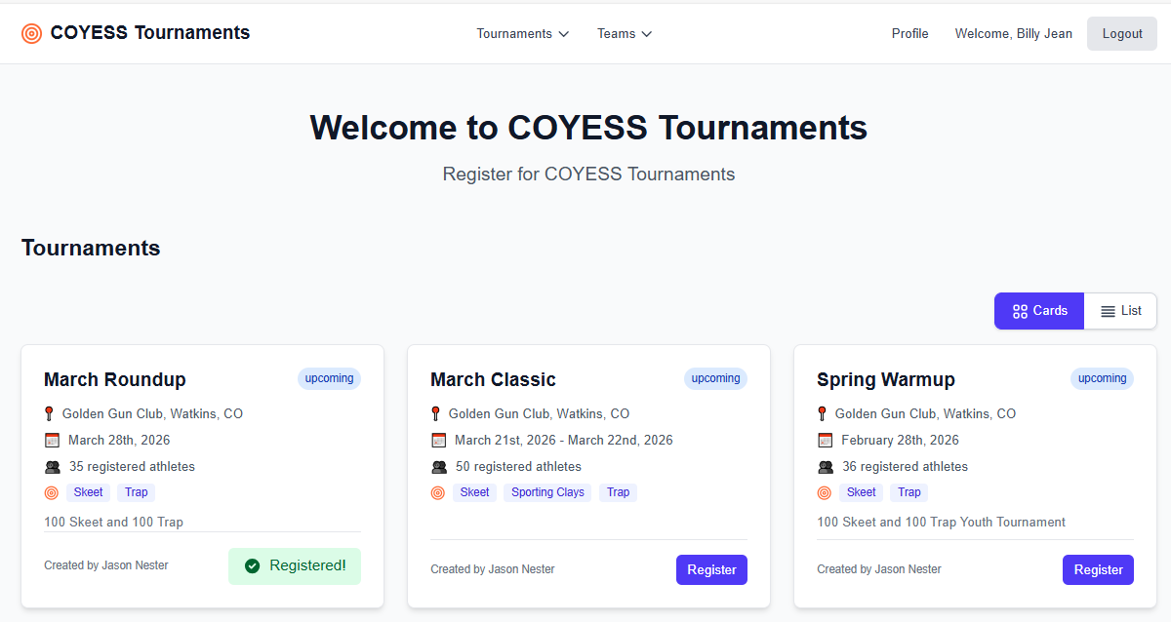

Hover over the tournament name and click on it and it should open a page showing your registration details. Below you can see that presently you are not squadded yet. Check back regularly to see what your shooting times were scheduled for you. Either your coach or the tournament administrator will squad you no later than a day or two before the tournament.
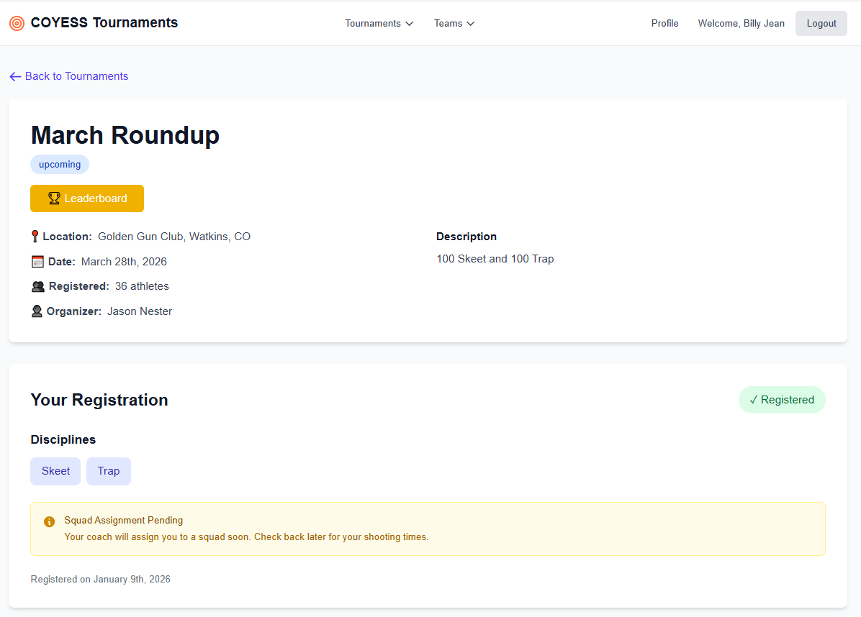

Once you have been squadded you should see the details on your tournament registration page. It should look like the below. It will provide the following information:
- your shooting time for each event,
- the field you are shooting on,
- what squad team you are on,
- the division you are shooting in
- and your shooting position in the squad
You will also notice the Leaderboard button. Only athletes and coaches with logins can see tournament results. During the tournament you can use the Leaderboard to check your scores against the other shooters in the tournament. Just select the Leaderboard button to be taking to the scores.
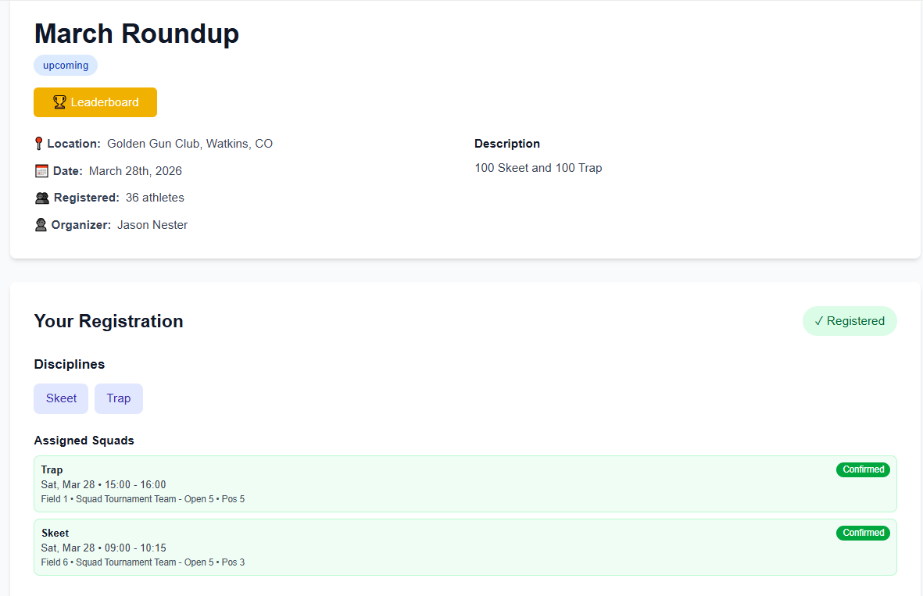

The Leaderboard automatically will rotate scores between the different options. You can Pause the score rotation in the top left corner. You can select the buttons at the top to see different scores. Make sure you select the event you want to review as well (skeet, trap, etc) from the secondary menu bar below the top menu bar.
